Ans 1.

Report view page

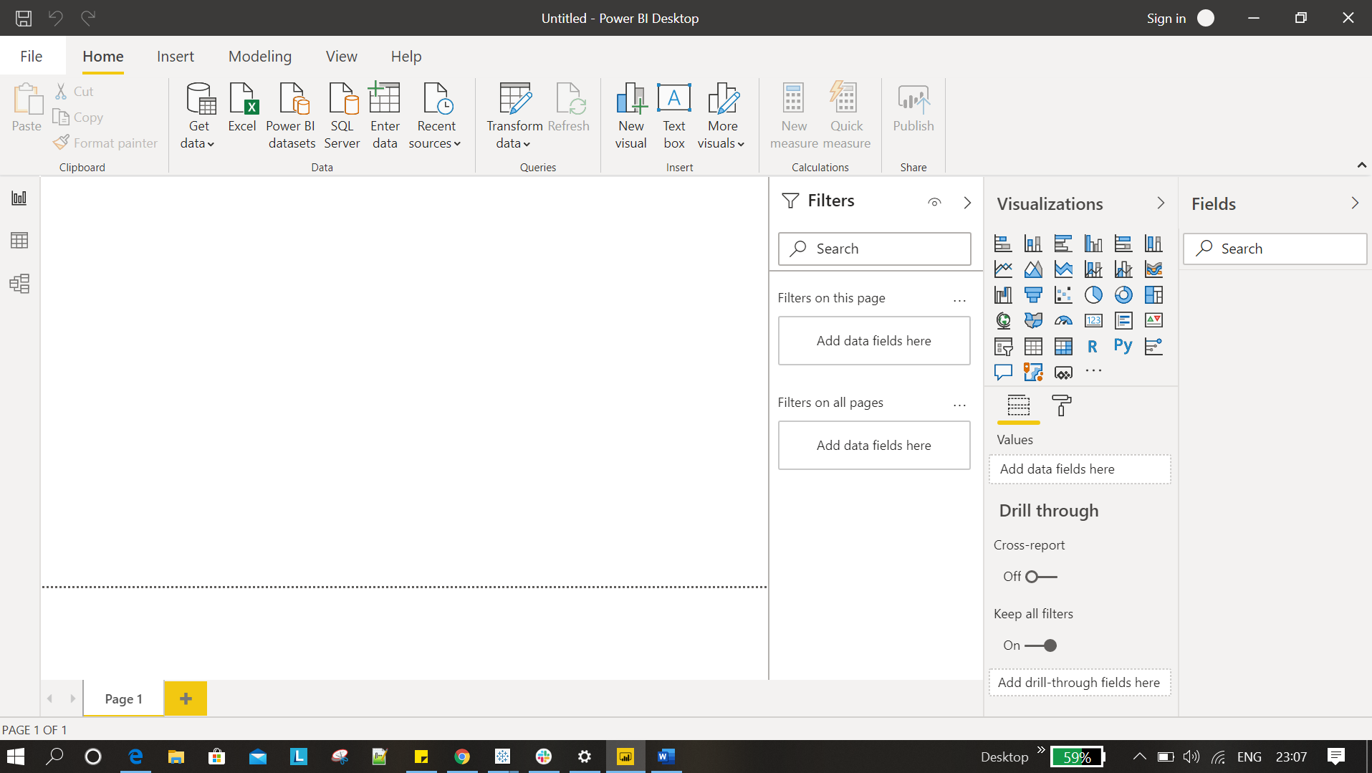

Ans 2.

Report view



Data View

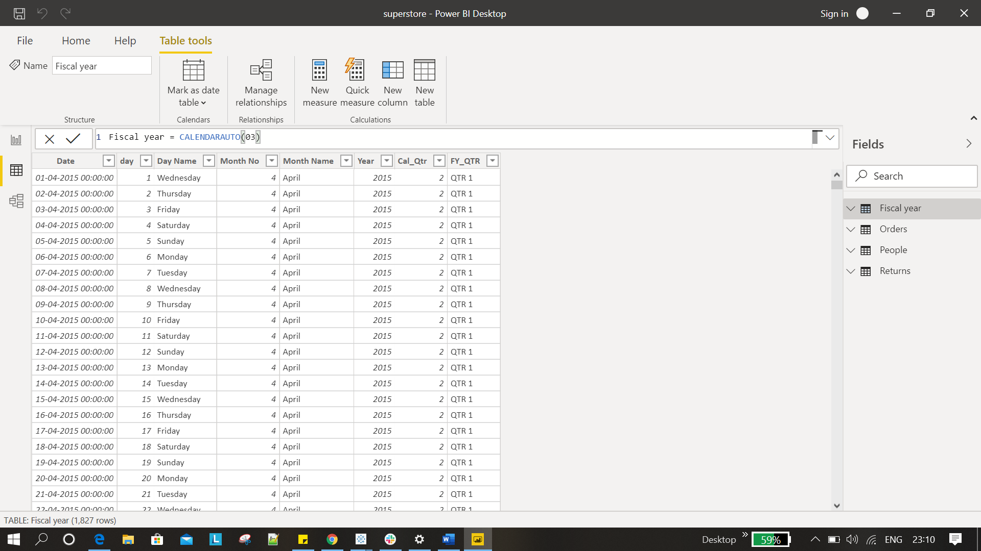

Model View

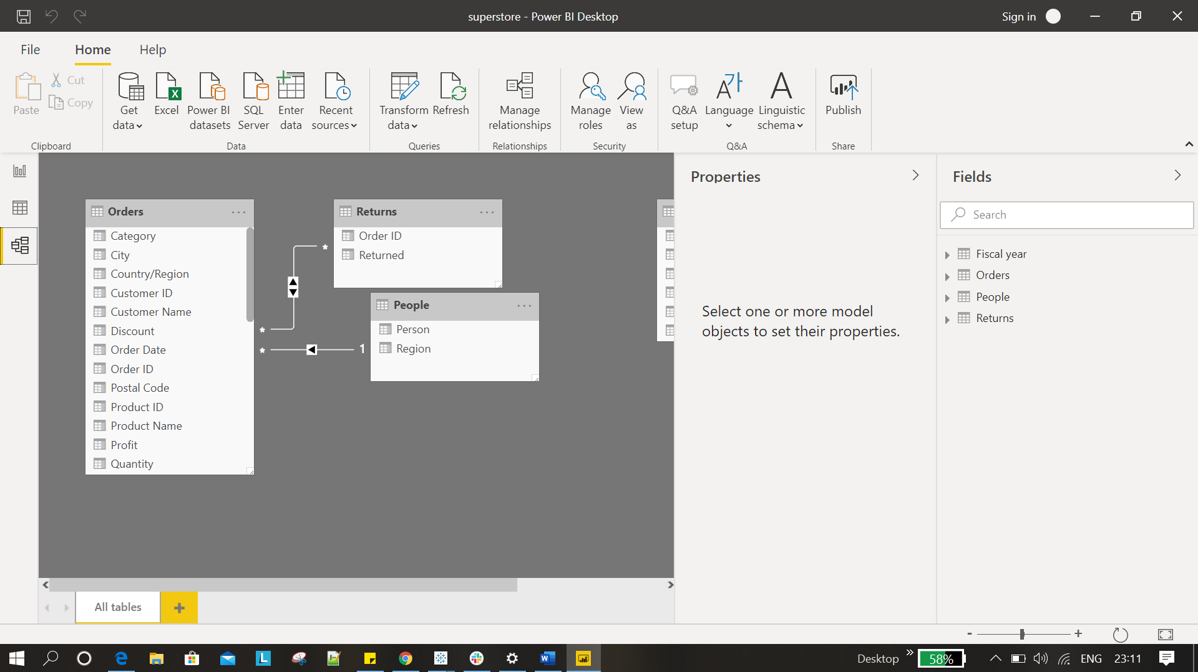

Power Query Editor

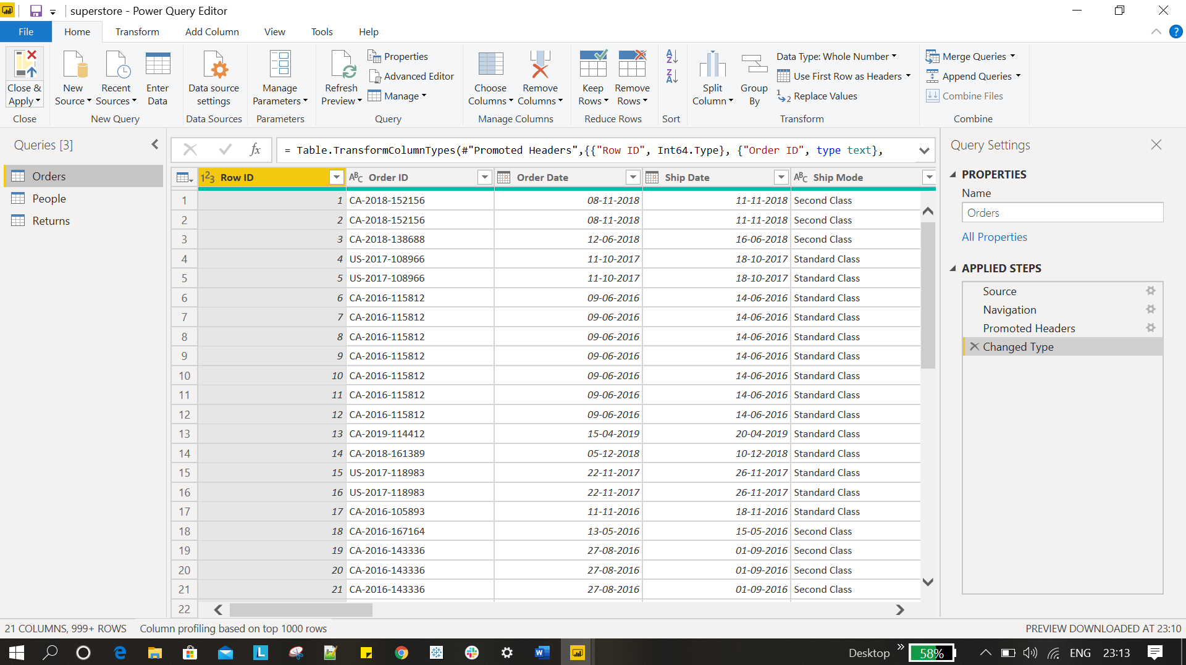

Advance Editor

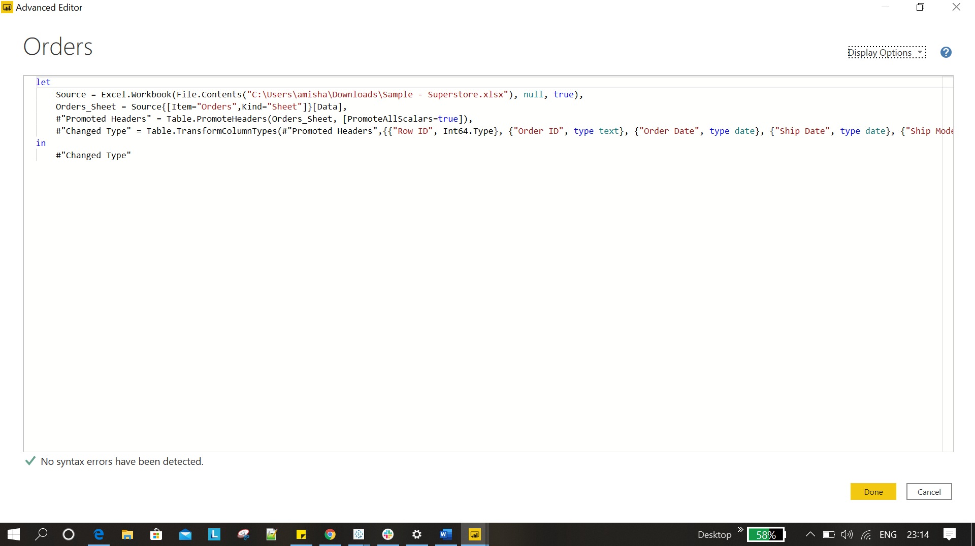

Ans 3 :- Power BI pricing:-

1. Power BI Desktop - Free
2. Power BI Pro - 660/ monthly
3. Power BI Premium - 330190/- Monthlly